Anonymous Proxy

🔐 What is an Anonymous Proxy?
# Source: Chatgpt (GPT-5-Mini) at [1/16/2026]
An Anonymous Proxy is a proxy server that hides your IP address from the websites you visit, helping protect your identity and privacy online.

🔎 How It Works:
# Source: Chatgpt (GPT-5-Mini) at [1/16/2026]
When you use an anonymous proxy:
- Your request goes to the proxy server first.
- The proxy forwards your request to the target website.
- The website only sees the proxy server's IP — not yours.

🛡️ Key Features:
# Source: Chatgpt (GPT-5-Mini) at [1/16/2026]
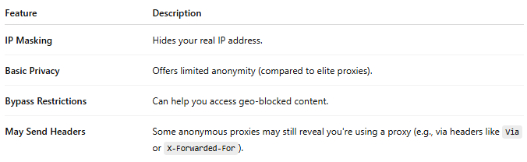
Feature | Description
IP Masking | Hides your real IP address.
Basic Privacy | Offers limited anonymity (compared to elite proxies).
Bypass Restrictions | Can help you access geo-blocked content.
May Send Headers | Some anonymous proxies may still reveal you're using a proxy (e.g., via headers like Via or X-Forwarded-For).

📊 Types of Proxy by Anonymity Level:
# Source: Chatgpt (GPT-5-Mini) at [1/16/2026]
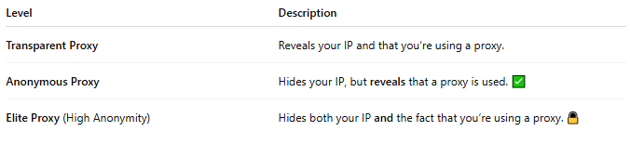
Level | Description
Transparent Proxy | Reveals your IP and that you’re using a proxy.
Anonymous Proxy | Hides your IP, but reveals that a proxy is used. ✅
Elite Proxy (High Anonymity) | Hides both your IP and the fact that you’re using a proxy. 🔒

🧠 Use Cases:
# Source: Chatgpt (GPT-5-Mini) at [1/16/2026]
- Hiding identity while browsing.
- Circumventing basic website blocks or censorship.
- Avoiding basic tracking mechanisms.

If you need stronger privacy or anonymity (e.g. for activism or sensitive communications), you might consider:
- Elite Proxies
- VPNs
- Tor Network

